

**FPT ACADEMY INTERNATIONAL**

**FPT – APTECH COMPUTER EDUCATION**

Project:

JADON EVENT MANAGEMNT WEBSITE



WEBSITE’S USER GUIDE

Class code:

Curriculum: 6715

Team: Group 2

Hoang Toan Thang (Team Leader) Student1236866

Quach Gia Lam Student1235029

Nguyen Ngoc Thach Student1225467

Instructor:

Le Mong Thuy

December – 2019

Contents

7. User Guide 3

7.1. Website installation 3

7.2. Over view 4

7.3. Fixed Contents 5

7.3.1. Header 5

7.3.2. Footer 7

7.4. Main pages 8

7.4.1. Home 8

7.4.2. Portfolio 10

7.4.3. Services 15

7.4.4. Team 19

7.4.5. Gallery 21

7.4.6. Press 23

7.4.7. Review 24

7.4.8. Contact 25

7.5. Sub pages 27

7.5.1. Turn key premium service 27

7.5.2. Limited service 28

7.5.3. A la carte 29

7.5.4. Service tasks of corporate 31

7.5.5. Service tasks of private 32

7.5.6. Service tasks of school & non-profit 33

7.5.7. Service tasks of wedding 34

7.5.8. Under construction 35

7.5.9. About this website 36

# User Guide

## Website installation

To install *Jadon* website, users need to do the following steps:

1. Download the file rar*eProject – Jadon by Group 2 (FPT Aptech HCM)*via_this_link: <https://drive.google.com/file/d/16QMxdl0uk1DZm0oZZm_se7MVGopR1fQi/view>
2. Extract the file rar: *eProject – Jadon by Group 2 (FPT Aptech HCM)*
3. Open the folder *jadon-191215*
4. 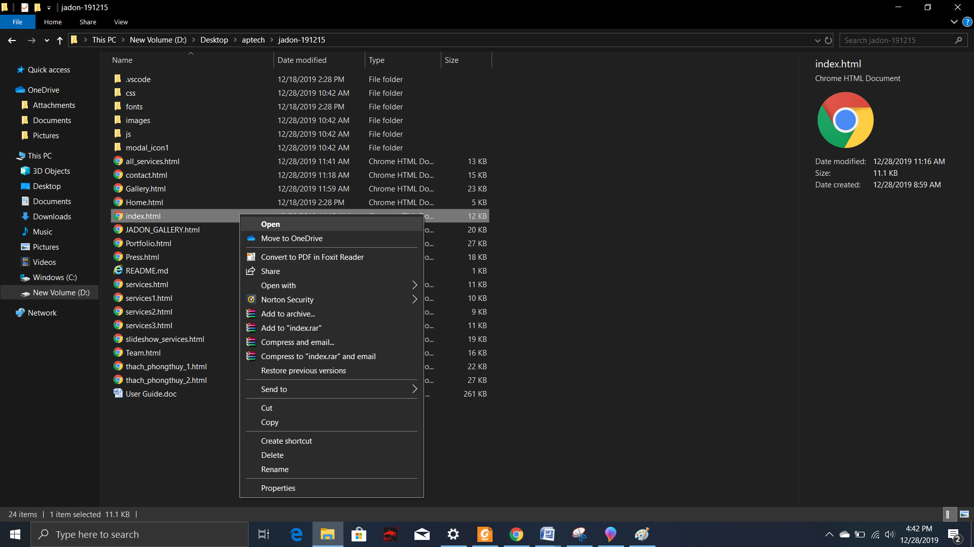Open *Index.html* file to start the website as below illustration

## Over view

There total 15 pages includes 8 main pages and 7 sub-pages in the website to tell everything about Jadon Event Management. All of which is to answer the following questions:

1. Who is Jadon?
2. What does(/can) Jadon do for me?
3. What kinds of work has Jadon done?
4. What is the quality of Jadon’s works?
5. How can I talk to Jadon now?

Below is the how the content of pages was designed around these questions

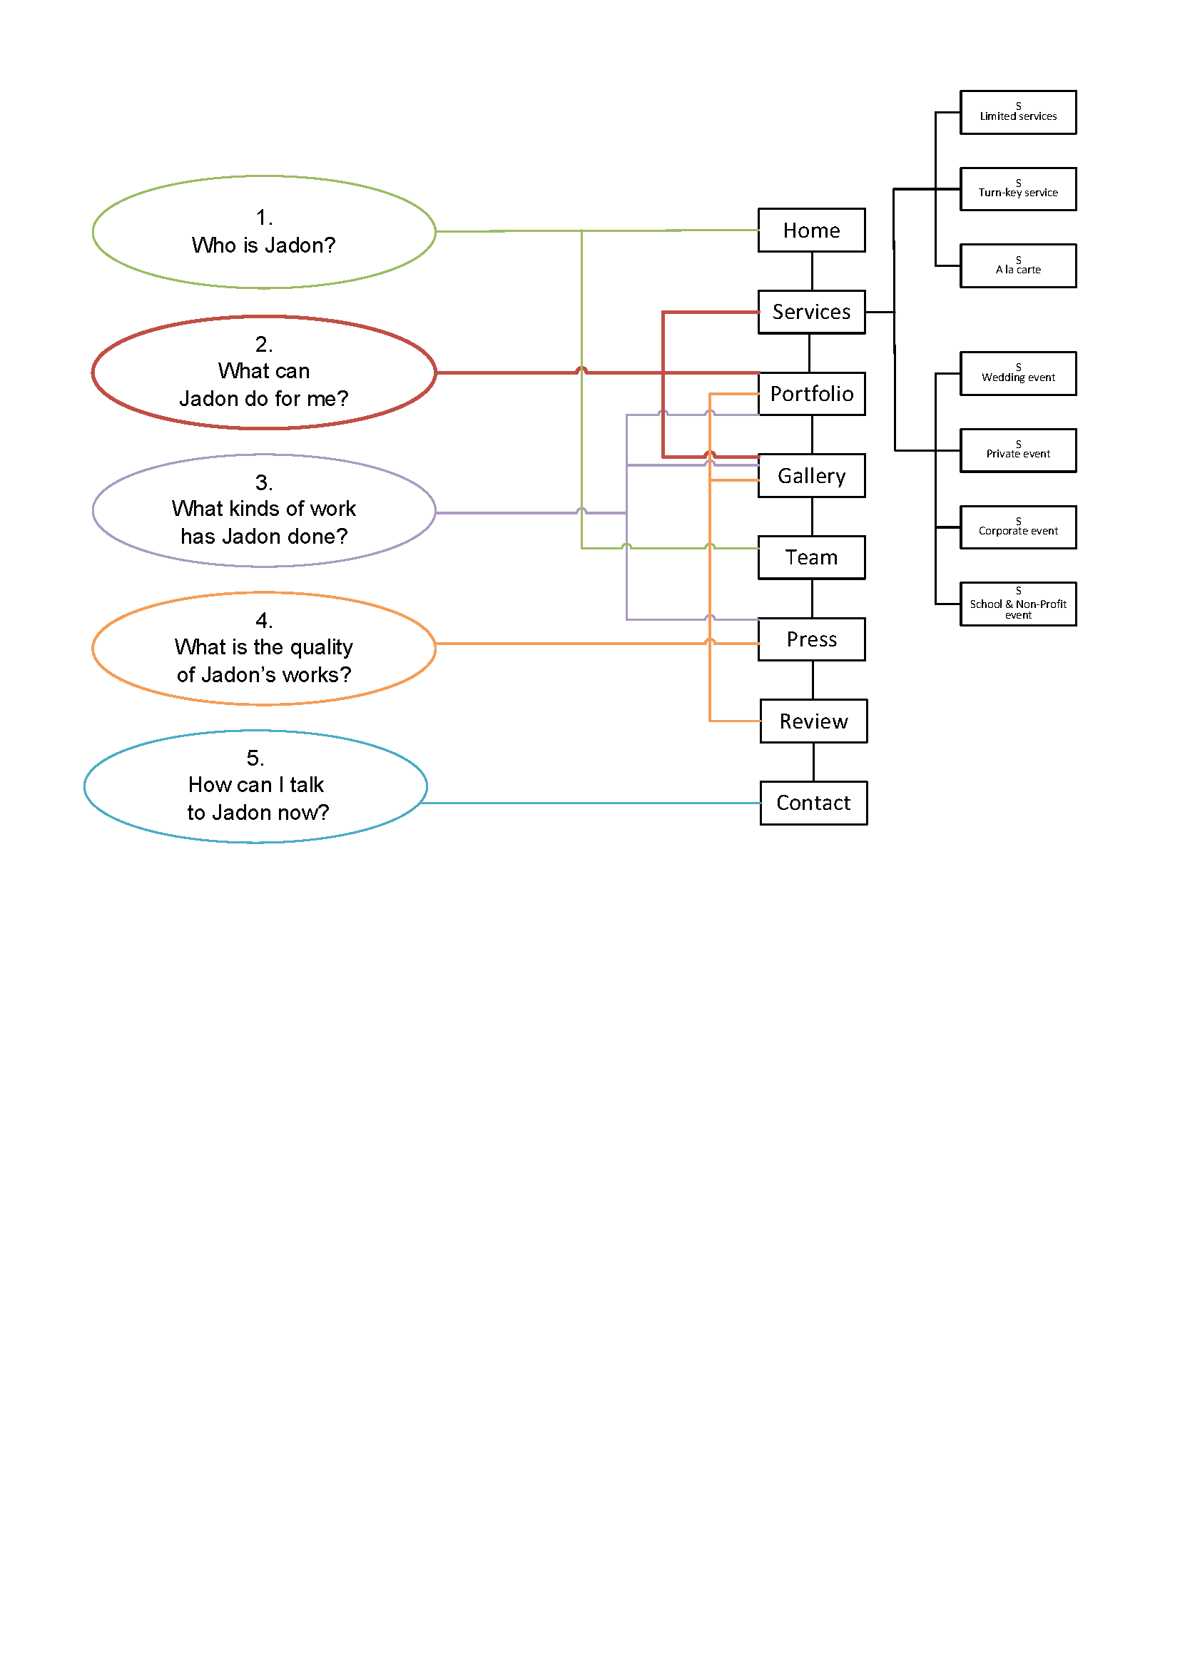

## Fixed Contents

Fixed contents are information that is displayed on every page. This information is so important to Jadon that it virtually is in front of the viewer all the time to access. They are in **header** and **footer** of the web pages.

### Header

Header is on top of every page. It contains Site Map Icon, Top Website Navigation Menu, Jadon Logo, Link to Message Form, Link to Email-to-Jadon action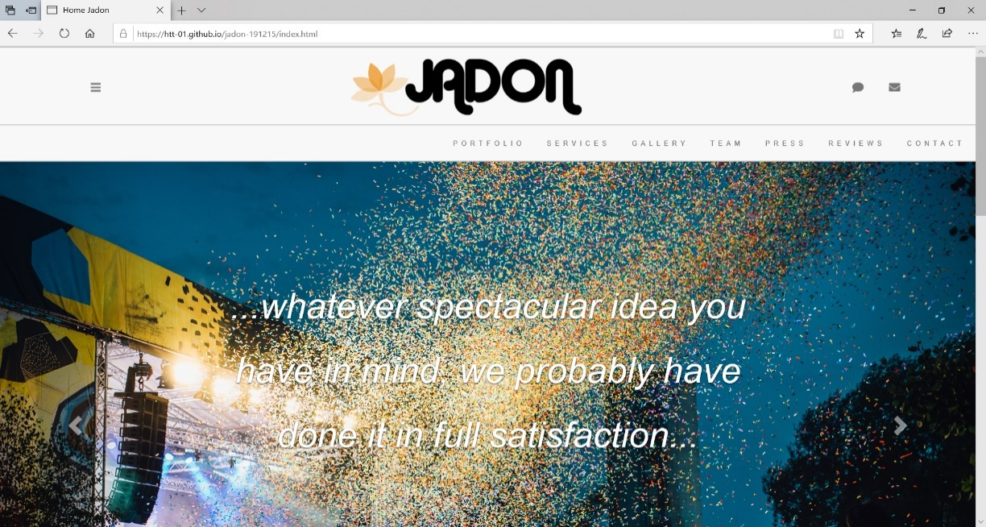

|  |  |  |
| --- | --- | --- |
| **Site Map Icon** |  | |
|  |  | Menu of Site Map  This menu contains links to all pages in this website. From here the user can get to any wehre within Jadon’s website. |
|  | | |
| **Top Website Navigation Menu** | This menu contain links to Main Pages of Jadon’s website | |
|  | | |
|  | | |
| **Jadon Logo** | Logo of Jadon is the link to go back to Home page | |
|  |  | |
|  | | |
| **Link to Message Form** | This icon is to pop up the **Feedback Form** for viewer to write to Jadon or for them to book an event | |
|  |  | |
|  | | |
| **Link to Email-to-Jadon** | This icon will start the email app on user computer, compose a new email with Jadon’s email as the receiver. | |
|  |  | |

### Footer

Footer is in the bottom of every page. It contains Link-to-Jadon-social-account Menu, Bottom Website Navigation Menu, Website Copyright Clause and Link to about-this-website.

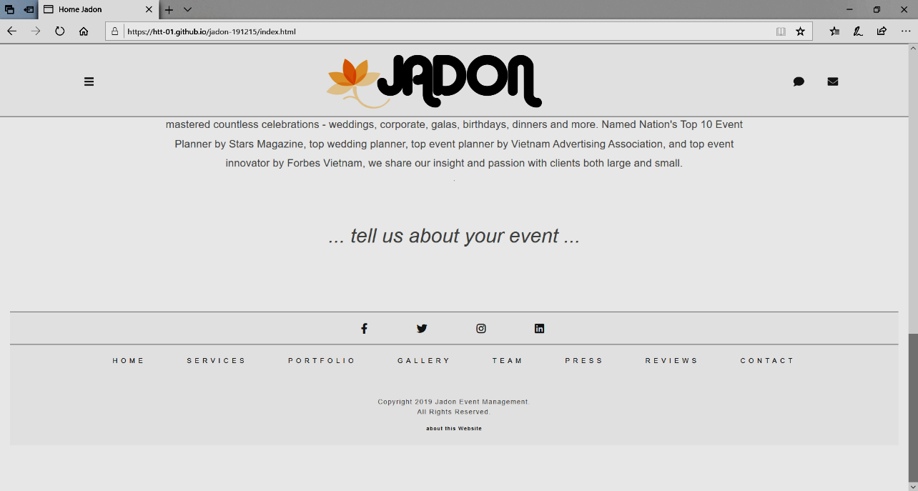

|  |  |
| --- | --- |
| **Link-to-Jadon-social-account Menu** | This menu contain links to Jadon’s account at facebook, twitter, pinterest and LinkedIn |
|  |  |
|  | |
| **Bottom Website Navigation Menu** | This menu contains 8 links to Main Pages of Jadon’s website |
|  | |
|  | |
| **Website Copyright Clause** |  |
|  |  |
|  | |
| **Link to about-this-website** | This text will link to the page containing message of the author of this website |
|  |  |

## Main pages

The website is divided into 8 main pages. They represent the functions of a normal website of business/company who provides services to customer:

### Home

This is the first page the viewer will see. It reflects Jadon’s first impression to viewer. This page contain introduction and abstract about Jadon. Detail content comprises of:

**Image slider**

|  |  |
| --- | --- |
|  | Slide 1:  Short message from Jadon to viewer |
|  | Slide 2:  Text “Portfolio” linked to Main page Portfolio |
|  | Slide 3:  Text “Services” linked to Main page Services |
|  | Slide 4:  Text “Gallery” linked to Main page Gallery |
|  | Slide 5:  Text “Team” linked to Main page Team |
|  | Slide 6:  Text “Team” linked to Main page Team |
|  | Slide 7:  Text “Contact” linked to Main page Contact |
|  | Slide 8:  Text “Write us” to open up Feddback form |

**Introduction about Jadon**

|  |  |
| --- | --- |
| Introduction paragraph |  |
|  | |

**Invite message to viewer**

|  |  |
| --- | --- |
|  | |
| **Link “tell us about your event”** | to open up Feddback form |

### Portfolio

This page is the capability statement of Jadon. This page presents to the user the experience in four main categories of Jadon’s business: corporate, private, school & non-profit, and wedding. Each of these categories contain 3 to 6 projects done by Jadon. The fifth category shows other types of event and the that Jadon’s capability is not limited to the above four categories. Detail content includes:

**Image slider**

|  |  |
| --- | --- |
|  | Slide 1:  Welcome slide, indicating that the page is to show Jadon’s works. |
|  | Slide 2:  Text “Corporate” linked to Corporate section of this page. |
|  | Slide 3:  Text “School & Non-profit” linked to School & Non-profit section of this page. |
|  | Slide 4:  Text “Private” linked to Private section of this page |
|  | Slide 5:  Text “Wedding” linked to Wedding section of this page |
|  | Slide 6:  Text “…how about…” linked to “…how about…” section of this page |

**Opening Statement for Portfolio**

|  |  |
| --- | --- |
| Opening paragraph for Portfolio |  |
|  | |

**Categories in Portfolio Main Page**

|  |  |
| --- | --- |
| Corporate | |
| Corporate section. 3 projects, each linked to pop-up slideshow of a project. | Pop-up slider    Bottom of the section is the link to section “Corporate” of the main page Gallery |
| School & Non-profit | |
| School & Non-profit section. 6 projects, each linked to pop-up slideshow of a project. | Pop-up silder    Bottom of the section is the link to section “school & non-profit” of the main page Gallery |
| Private | |
| Private section. 3 projects, each linked to pop-up slideshow of a project | Pop-up silder    Bottom of the section is the link to section “Private” of the main page Gallery |
| Wedding | |
| Wedding section. 3 projects, each linked to pop-up slideshow of a project | Pop-up silder    Bottom of the section is the link to section “Wedding” of the main page Gallery |
| Other types | |
| “..how about…” section. 2 projects, each linked to pop-up slideshow of a project | Pop-up silder    Bottom of the section is the link to section “Exhibition & Convention” of the main page Gallery |

### Services

This page describes all need-to-know about the service of the company. There are two points the user is interested in: scope of service and service tasks of events.

* Scope of services:

This determines the level of involvement by Jadon in managing the event. There are 3 formats for the scope of service which are detailed in 3 sub-pages of the main page “Services” with corresponding names:

* + Turn key premium service:
  + Limited service
  + A la carte
* Service tasks of event

There are four types of events of which the services can be standardized into detailed lists of tasks. They are organized in 4 sub-pages of the main page “Services” with corresponding names:

* + Service tasks of corporate
  + Service tasks of private
  + Service tasks of school & non-profit
  + Service tasks of wedding

The physical content of the main page “Service” includes:

**Opening Statement for Services**

|  |  |
| --- | --- |
| Picture with text “Services” linked to opening statement of “Services” Main page | |
|  | |
| Opening statement: Services Offerings | |
|  | |
| links to **Service tasks of event**  in Opening statement | |
| Link to **Service tasks of Corporate**  open up  Sub-page service-corporate |  |
| Link to **Service tasks of Private**  open up  Sub-page service-private |  |
| Link to **Service tasks of School & Non-profit**  open up  Sub-page service-School & Non-profit |  |
| Link to **Service tasks of Wedding**  open up  Sub-page service-wedding |  |

**Scope of services**

|  |  |
| --- | --- |
| Sypnosis for 3 scopes | |
|  | |
| Link to sub-page  Turn key premium service |  |
| Link to sub-page  Limited Edition service |  |
| Link to sub-page  A la carte service |  |

### Team

In this page Jadon wants to present to the viewer the core team that makes all these works possible.

**Opening statement for Team**

|  |
| --- |
| Picture with text “Team” above opening statement of “Team” Main page |
|  |
| Opening statement: |
|  |

**Team member introduction**

|  |
| --- |
| Picture of team members with introduction text |
|  |
|  |

### Gallery

This page is the image stock for the whole website. The images are categorized in five types of event corporate, private, school & non-profit, exhibition & convention. The page includes:

**Title text “Gallery” and navigation menu**

|  |  |
| --- | --- |
| Title text “Gallery” and navigation menu | |
|  | |
|  | |
| The navigation menu link | |
| link | Target section |
|  | Each image of the section is a link to a project  sliedshow |
|  | Each image of the section is a link to a project sliedshow |
|  | Each image of the section is a link to a project sliedshow |
|  | Each image of the section is a link to a project sliedshow |
|  | Each image of the section is a link to a project sliedshow |

### Press

This page contain links to all press article relating to Jadon. They were divided into 3 most recent year 2019, 2018 and 2017.

|  |
| --- |
| Title text “Press” |
|  |
| Articles in 2019 |
|  |
| Articles in 2018 and 2017 |
|  |

### Review

This page contains reviews of Jadon’s customers

|  |
| --- |
| Title text “Review” |
|  |
| Review section |
|  |
| Text “…tell us about your event…” linked to feddback form |
|  |

### Contact

This page contains information for viewer to contact Jadon. It includes phone number and email address of various departments,

|  |
| --- |
| Title text “Contact” and opening paragraph |
|  |
|  |
| Jadon’s phone numbers, emails, address and Feedback fom |
|  |
| Location map |
|  |

## Sub pages

### Turn key premium service

This page is the sub-page of main page “Services”. It contains:

|  |
| --- |
| Background picture with Title text “Turn key Planning Services” which is linked to specification of “turn key premium service” |
|  |
| Specification of “turn key premium service” |
|  |
| Text “…tell us about your event…” linked to feddback form |
|  |

### Limited service

This page is the sub-page of main page “Services”. It contains:

|  |
| --- |
| Background picture with Title text “Limited Edition Planning Services” which is linked to specification of “Limited Edition Planning Services” |
|  |
| Specification of “Limited Edition Planning Services” |
|  |
| Text “…tell us about your event…” linked to feddback form |
|  |

### A la carte

This page is the sub-page of main page “Services”. It contains:

|  |
| --- |
| Background picture with Title text “À la carte” which is linked to specification of “À la carte” |
|  |
| Specification of “À la carte” |
|  |
| Text “…tell us about your event…” linked to feddback form |
|  |

### Service tasks of corporate

This page is the sub-page of main page “Services”. It contains:

|  |
| --- |
| Background picture with Title text “Corporate Events” which is linked to opening statement about Jadon’s corportate event service |
|  |
| opening statement about Jadon’s corportate event service |
|  |
| List of tasks for corporate event |
| Text “…our corporate portfolio…” linked to “corporate” section in main page “Gallery” |
|  |
| Text “…OR tell us about your event…” linked to Feedback form |
|  |

### Service tasks of private

This page is the sub-page of main page “Services”. It contains:

|  |
| --- |
| Background picture with Title text “Private Events” which is linked to opening statement about Jadon’s private event service |
|  |
| opening statement about Jadon’s private event service |
|  |
| List of tasks for private event |
|  |
| Text “…our private portfolio…” linked to “private” section in main page “Gallery” |
|  |
| Text “…OR tell us about your event…” linked to Feedback form |
|  |

### Service tasks of school & non-profit

This page is the sub-page of main page “Services”. It contains:

|  |
| --- |
| Background picture with Title text “School & Non-profit Events” which is linked to opening statement about Jadon’s School & Non-profit Events service |
|  |
| opening statement about Jadon’s School & Non-profit Events service |
|  |
| List of tasks for School & Non-profit Events |
|  |
| Text “…our school & non-profit portfolio…” linked to “school & non-profit” section in main page “Gallery” |
|  |
| Text “…OR tell us about your event…” linked to Feedback form |
|  |

### Service tasks of wedding

This page is the sub-page of main page “Services”. It contains:

|  |
| --- |
| Background picture with Title text “Wedding Events” which is linked to opening statement about Jadon’s Wedding Events service |
|  |
| opening statement about Jadon’s Wedding Events service |
|  |
| List of tasks for Wedding Events |
|  |
| Text “…our wedding portfolio…” linked to “wedding” section in main page “Gallery” |
|  |
| Text “…OR tell us about your event…” linked to Feedback form |
|  |

### Under construction

This page is displayed in cases where the link is not ready at the current time

|  |
| --- |
| Under-construction message |
|  |

### About this website

This page will display when user clicks on the link “about this website”

This Page contains message from the authors of this website regarding copyright, fact-check, intention, purpose and usage of this website and its materials.

|  |
| --- |
| About this website |
|  |